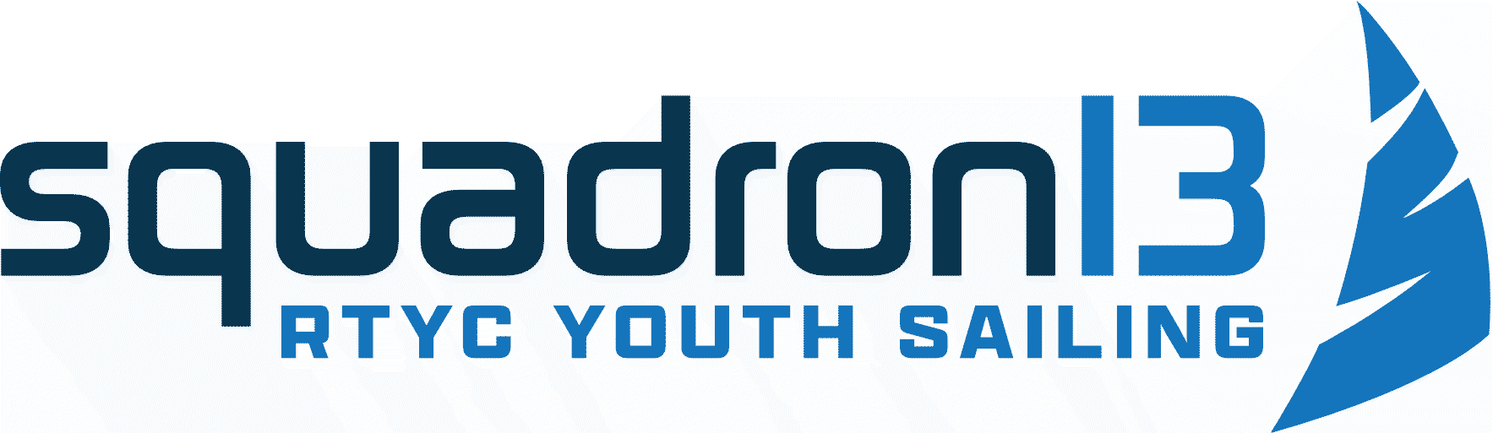
Joining Pack

Please complete the attached forms and return them to the Royal Torbay Yacht Club office.
Squadron 13 membership falls into our “Family Membership” this includes membership for parents/guardians and siblings of the Squadron 13 member.
All Juniors who intend to participate in the Club racing programme shall, in addition to the attached form, complete the entry process at rtyc.org/club-racing-2025
Parents / Guardians should also download, read and complete the Notice of Race and Sailing Instructions.

If you have any questions, please call us on 01803 292006 or email admin@rtyc.org

Please note: We need a separate booking form for each child.
Booking and Parental Consent form
Squadron 13 Saturday Training and Racing Sessions
Event name | Squadron 13
Venue | Royal Torbay Yacht Club
Event Coordinators | Ian Mills (SI)

PARTICIPANT CONTACT DETAILS
Name
Date of Birth
Address
Contact no.
As you are under 18, your parent or guardian must complete and sign the Parental/Guardian Agreement Form below

ABOUT THE PARTICIPANT
Do you have any previous boating experience or qualifications?
If yes, please give brief details.
Can you swim 25 metres?
In the interests of your safety do you have any medical conditions or physical or mental impairments that the organiser needs to be aware of that may affect your ability to take part in the Event?
Telephone number of emergency contact.

PARENT/GUARDIAN INFORMATION (head of family & emergency contact)
Name
Relationship to participant
Phone Number
Email address (this will be used for direct debits)

ADDITIONAL FAMILY MEMBERS INFORMATION
Please include anyone else you would like to add to the Family Membership (parents/guardians and any under 18s who all reside at the same address)
Name | Date of Birth | Relationship to participant | Email address (adults only)

BOOKING TERMS
- RISK STATEMENT
It must be recognised that sailing is by its nature an unpredictable sport and therefore inherently involves an element of risk. By taking part in the Events, you agree and acknowledge that:
- You are aware of the inherent element of risk involved in the sport and you accept responsibility exposing yourself to such inherent risk whilst taking part in the Events.
- You will comply at all times with the instructions of the Event Co-ordinator particularly with regard to handling of boats, wearing of buoyancy aids and the wearing of suitable clothing for the conditions.
- You accept responsibility for any injury, damage or loss to the extent caused by your own negligence.
- You will not participate in the Events if your ability to participate is impaired by alcohol, drugs or if you are otherwise unfit to participate.
- You will inform the Event Co-ordinator if there have been any changes to the information provided on this form at the time of the Events.
- The provision of patrol boat cover is limited to such assistance as can be practically provided in the circumstances;
- You are aware of any specific risks drawn to your attention by the Event Co-ordinator.

- CANCELLATION
You understand that the Event Co-ordinator may cancel or postpone the Events at any stage in the event of bad weather, equipment failure or otherwise.

- MISCONDUCT
You understand that the Event Co-ordinator may exclude anyone from a particular session and evict anyone from the premises who refuses to comply with these Booking Terms or who misconducts themselves in any way or who causes damage or annoyance to other persons.

- DATA PROTECTION
The Organiser has a Data Privacy Policy which can be found at http://rtyc.org/privacy/
Your data will be stored and used in accordance with that policy.

The information you provide in this form will be used to facilitate your participation in the Events and to contact you. The Organiser would also like to include your contact details on a mailing list to make you aware of future events. We may also use social media channels to contact you or group messaging services E.g., WhatsApp. This will be for the transfer of information relating to the training or racing events.

If you would like to be included on the RTYC club mailing list, please tick here.
If you wish to withdraw your agreement at any time, please contact admin@rtyc.org

AGREEMENT
I confirm that I have read and fully understand the above Booking Terms and agree to comply with them.

Signed………………………………………….. (The Participant) Date

Medical treatment
I give permission to the organisers to administer any relevant treatment or medication to the above-named participant when or if necessary.

In an emergency situation I authorise the organisers to take my child to hospital and give my full permission for any treatment required to be carried out in accordance with the hospital’s diagnosis. I understand that I shall be notified, as soon as possible, of the hospital visit and any treatment given by the hospital.

Use of your child’s image
The Organiser may arrange for images or videos to be taken at the Event and published on the Event or Organiser’s website or social media channels to promote the Event or Organiser.

If you agree to the use of images of your child being used for this purpose, please tick here.

If you agree to the use of images of your child being used, please confirm below that your child is not under a court order which may prevent their image being published.
I confirm that my child is not under a court order which may prevent their image from being published.

If you later wish to withdraw your agreement, please contact admin@rtyc.org
Please be aware that if you later decide to withdraw your agreement it will not be possible to remove your image from any printed material in circulation, or until the next edition or print of the item containing your image is released.
By agreeing to images being used, you agree to assign any copyright or any other right of ownership of these images to the Organiser.

Permission for Child to leave Club
If you agree to your child being able to make their own way home from Royal Torbay Yacht Club please tick here.

If you will collect your child from the Royal Torbay Yacht Club please tick here

PARENTAL/GUARDIAN AGREEMENT (if under 18)

I agree that …………………………………….(PLEASE PRINT NAME) may take part in the Event. I confirm that I have read through the above conditions with them and that they understands and agree with them. I also confirm that they may take part in the Event with my full agreement that that the particulars given above are correct and complete in all respects.

Signed
Parent/Guardian name

Date

Direct debit payments will be set up via Smart Club Cloud. The ‘Head of the Family’ and other adults in the Family membership will receive several emails from Smart Club Cloud containing usernames and passwords (please check your Spam Folder for these).
Information on how to set up the Direct Debit will be emailed to you from the Office.
It is the responsibility of the Participant or Parent/Guardian to ensure this is set up. If this is not processed correctly, the Participant will be removed from Squadron 13.

If you wish to withdraw from Squadron 13, please inform the Event Co-Ordinator and the Royal Torbay Yacht Club Office by emailing admin@rtyc.org. It will be the responsibility of the Participant or Parent/Guardian to cancel direct debits. RTYC will not refund any money that has been paid if the direct debit is not cancelled.
If you declared that you have a medical condition or physical or mental impairment that the organiser needs to be aware of because it may affect your ability to take part in the Events please provide details below.

MEDICAL INFORMATION AND IMPAIRMENTS

SPECIAL CATEGORY DATA
I confirm that I have given the Organiser the medical information listed on this page (if any) for the purposes of my participation in the Event. I understand that this information will only be used for that purpose and will be retained for as long as necessary to comply with the Organiser’s legal obligations.

I agree (Please delete as appropriate)

