UK RS FEVA CLASS ASSOCIATION
GP4 Spring Championships
Saturday 23rd – Sunday 24th March 2024

WELCOME and JOINING INSTRUCTIONS.

We are looking forward to welcoming you all to Torquay and to the Royal Torbay Yacht Club (RTYC) . The following notes and harbour plan will help you when arriving and during your time with us.

PRIOR TO TRAVELLING
- There are extensive roadworks being carried out around Torquay Harbou, you are strongly advised to check out the Harbour website page for latest information and any updates.
Tor Bay Harbour - Home (tor-bay-harbour.co.uk)

UPON ARRIVAL IN TORQUAY
- Follow the road signs to the Harbour and enter Beacon Quay (with the Harvester Pub on your left), at the barrier you will be welcomed by RTYC volunteers.
- Drive along Beacon Quay to the far end.
- RTYC volunteers will be on hand to direct and assist you late afternoon on Friday 22nd March, and from 0800 on Saturday 23rd March.
- At other times please press the buzzer by the barrier to request access.
- For access outside these hours or you experience difficulty please contact events@rtyc.org or telephone 07970353660 in advance.
- Dinghy Parking will be on Haldon Pier.
- Once you have dropped off your boat, your car should be parked in the nearby car park as there is strictly NO PARKING on the harbourside. The car park uses the Ringo payment app.

CHECK IN ON THE HARBOURSIDE
- All competitors are required to CHECK IN upon arrival with the Beachmaster on Haldon Pier or on Saturday morning if you have arrived late on Friday evening.
- The Beachmaster will be based near the Flagpole and halyards close to the slipway.
- Coloured labels with Sail Number will be secured to your trolley for ease of identification when coming ashore.

REGISTRATION
- Registration will take place in the Committee Room on the ground floor of Royal Torbay Yacht Club
- The times from 09.00 to 10.00 on Saturday 23rd March.

CLUB ACCESS & INFORMATION
- At registration you will be given club information including WiFi
- For security reasons the front door should be kept closed at all times, please use #1478 to gain access at the front door and garden entrance at the rear of th

BAR AND CATERING
- The club will be open throughout the event, and we hope you will make good use of it.
- An event supper will take place in the Corinthian Room at 19.00 on Saturday 23rd March.
Menu choices and booking details can be found here RS Feva Class – Spring Championship | Royal Torbay Yacht Club (rtyc.org)
- Bar Food will be available in the Saturday and Sunday lunchtimes.
- Food and drink not purchased from the club may not be consumed on club premises.

CHANGING ROOMS
- Male Changing Rooms, Showers and Toilets are located on the ground floor
- Female Changing Rooms, Showers and Toilets are located on the first floor, accessed from the stairs on the left of the entrance hall.
- Sailing bags and clothing should not be left in the changing rooms.

EVENT WEBSITE
- RS Feva Class – Spring Championship | Royal Torbay Yacht Club (rtyc.org)

USEFUL LOCAL INFORMATION
- Tor Bay Harbour - Torquay Harbour (tor-bay-harbour.co.uk)
- Car Parking Information and Passes
- Visitor Information Centre
- Where to Stay on The English Riviera

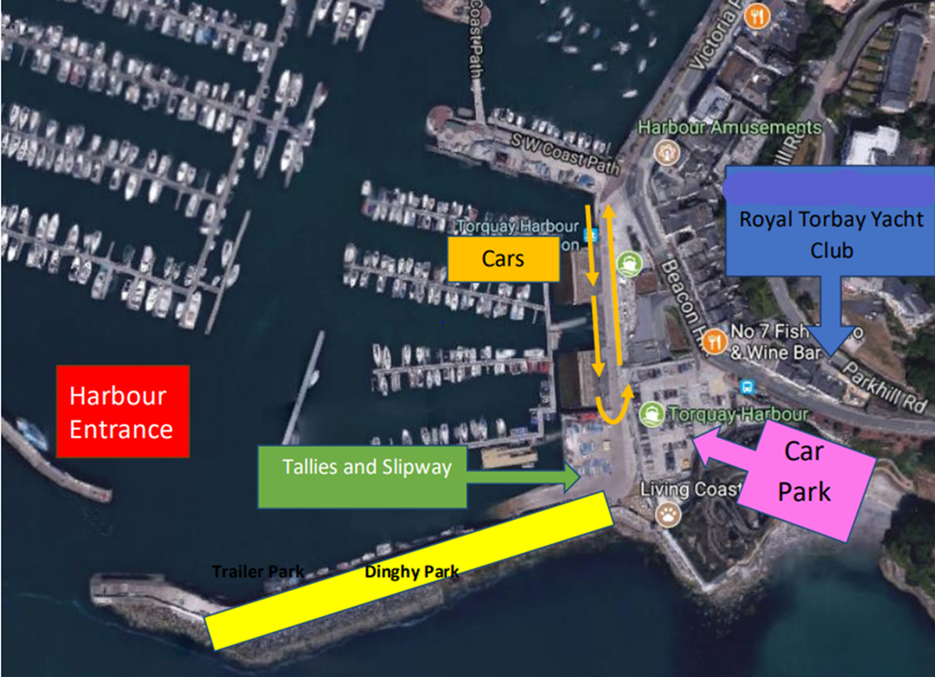

Royal Torbay Yacht Club
12 Beacon Terrace, Torquay, TQ1 2BH Tel. +44(0)1803292006 Email. events@rtyc.org

